Algorithms and Data Structures

Summative Assessment

Module Grader Source Code:

// Part A of Algorithms and Data Structures Assessment.

// The purpose is to assign a grade to university modules.

**import** java.util.Scanner;

**public** **class** ModuleGrader {

**public** **static** **void** main(String[] args) {

*startModuleGrading*();

}

**public** **static** **void** gradeModule()

// In gradeModule any mark in 0-100 is awarded a grade based on grading criteria.

{

//Scanner imported to enable user input.

System.***out***.println("Please enter initial module grade value to begin:");

Scanner keyboard = **new** Scanner(System.***in***);

**double** input=0;

input = keyboard.nextDouble();

**if** (input > 0 && input < 100)

System.***out***.println("Acknowledged.");

**if** (input < 0 && input > 100)

System.***out***.println("Invalid Input.");

**if** (input > 0 && input <39)

System.***out***.println("Your grade is Outright fail.");

**if** (input > 40 && input < 49)

System.***out***.println("Your grade is Compensatable fail.");

**if** (input > 50 && input < 59)

System.***out***.println("Your grade is Satisfactory.");

**if** (input > 60 && input < 69)

System.***out***.println("Your grade is Good.");

**if** (input > 70 && input < 100)

System.***out***.println("Your grade is Excellent.");

}

**public** **static** **void** getValidModuleMark()

// In getValidModuleMark any mark in 0-100 is awarded a grade based on grading criteria.

// The user is prompted y to continue n to exit program.

{

Scanner keyboard = **new** Scanner(System.***in***);

String answer;

**boolean** valid = **false**;

**double** input=0; {

**while** (!valid) {

**do** {

System.***out***.println("");

System.***out***.println("Please enter a positive value < 100:");

input = keyboard.nextDouble();

**if** (input > 0 && input <100) {

valid = **true**;

System.***out***.println("Acknowledged.");

**if** (input > 0 && input <39)

System.***out***.println("Your grade is Outright fail.");

**if** (input > 40 && input < 49)

System.***out***.println("Your grade is Compensatable fail.");

**if** (input > 50 && input < 59)

System.***out***.println("Your grade is Satisfactory.");

**if** (input > 60 && input < 69)

System.***out***.println("Your grade is Good.");

**if** (input > 70 && input < 100)

System.***out***.println("Your grade is Excellent.");

}

**else** {

System.***out***.println("Invalid input.");

}

System.***out***.println("");

System.***out***.println("Do you want to continue? y/n");

System.***out***.println("");

System.***out***.println("Mark your selection and press enter:");

answer = keyboard.next();

}

**while** (answer.equals("y"));

**if** (answer.equals("n"))

System.***out***.println("");

System.***out***.println("Program terminated");

**return**;

} } }

**public** **static** **void** startModuleGrading()

// In startModuleGrading the previous methods are called.

{

System.***out***.println("*********** Module Grading Program *********");

System.***out***.println("");

*gradeModule*();

*getValidModuleMark*();

} }

Evidence for Testing Module Grader Class:

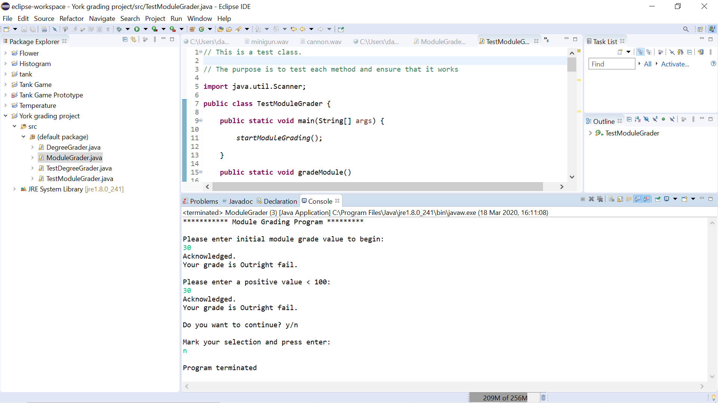

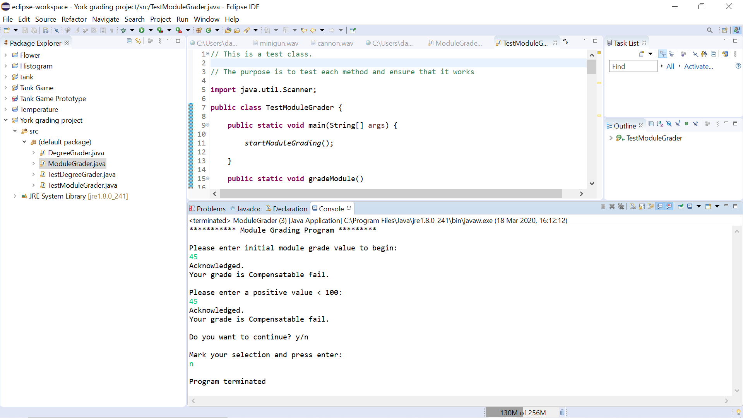

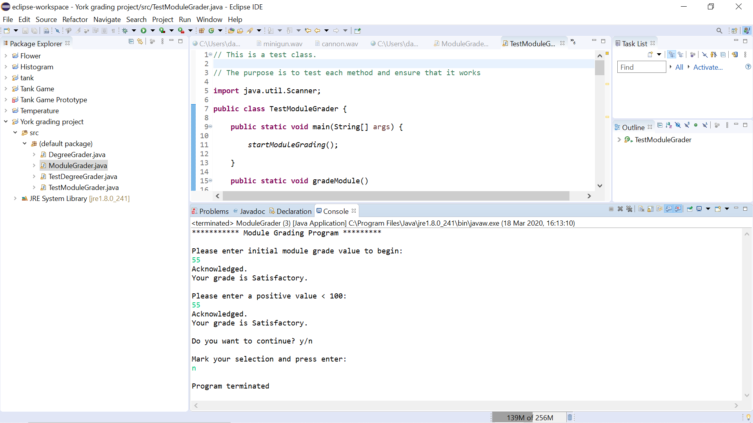

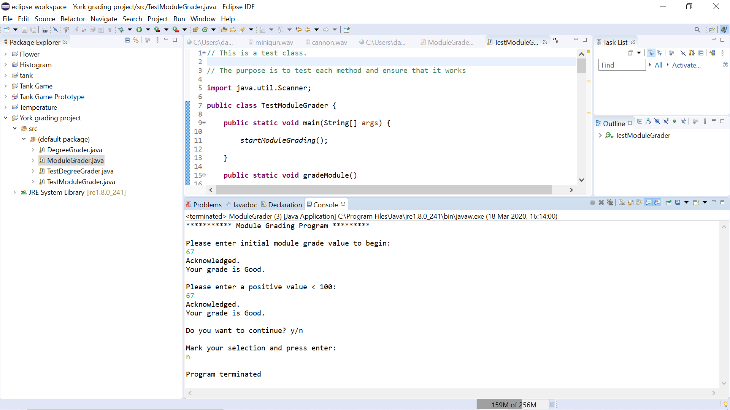

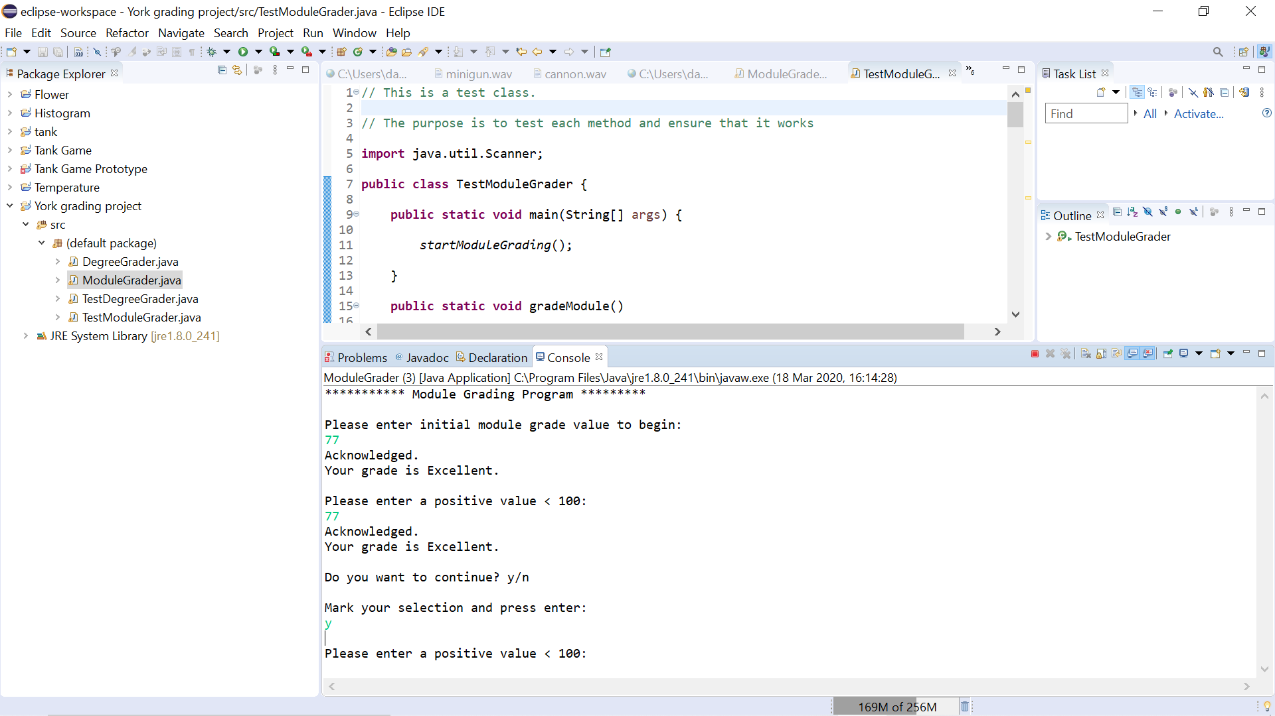

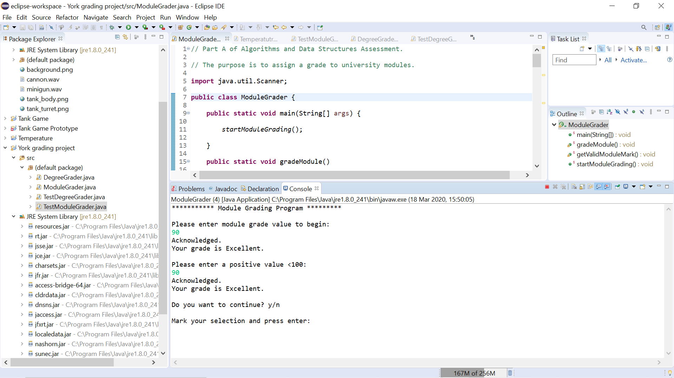

Degree Grader Source Code:

//Part B of Algorithms and Data Structures Assessment.

//The purpose is to grade degrees.

**import** java.util.Scanner;

**public** **class** DegreeGrader {

**public** **static** **void** main(String[] args) {

*startDegreeGrading*(); }

**public** **static** **void** gradeDegree()

// In gradeDegree users are asked to provide averages and failed modules.

// Users are awarded fail, pass, merit or distinction based on input.

// The user is prompted y to continue n to exit program.

{

Scanner keyboard = **new** Scanner(System.***in***);

String answer;

**boolean** valid = **false**;

**double** moduleaverage=0;

**double** ISMmoduleaverage = 0;

**double** failedcredits = 0;

**double** failedmodules = 0;

**double** result = 0;

**double** result2 = 0;

{

**while** (!valid) {

**do** {

System.***out***.println("");

System.***out***.println("Please enter module average 0-100 to begin:");

moduleaverage = keyboard.nextDouble();

**if** (moduleaverage > 0 && moduleaverage < 100) {

valid = **true**;

System.***out***.println("Acknowledged.");

System.***out***.println("");

System.***out***.println("Enter ISM module average 0-100:");

ISMmoduleaverage = keyboard.nextInt();

**if** (ISMmoduleaverage > 0 && ISMmoduleaverage < 100)

System.***out***.println("Acknowledged.");

**else**

System.***out***.println("Invalid input.");

System.***out***.println("Enter failed credits 0-100:");

failedcredits = keyboard.nextInt();

**if** (failedcredits > 0 && failedcredits < 100)

System.***out***.println("Acknowledged.");

**else**

System.***out***.println("Invalid input.");

System.***out***.println("Enter failed modules 0-50:");

failedmodules = keyboard.nextInt();

**if** (failedmodules > -1 && failedmodules < 100)

System.***out***.println("Acknowledged.");

**else**

System.***out***.println("Invalid input.");

result = failedmodules+failedcredits;

result2 = ISMmoduleaverage + moduleaverage;

**if** (moduleaverage > 70 && moduleaverage < 100 && ISMmoduleaverage > 70 && ISMmoduleaverage < 100 && failedcredits < 30 && failedmodules < 1)

System.***out***.println("You got a distinction.");

**if** (moduleaverage > 60 && moduleaverage < 69 && ISMmoduleaverage > 60 && ISMmoduleaverage < 69 && failedcredits < 15 && failedmodules < 40)

System.***out***.println("You got a merit.");

**if** (moduleaverage > 50 && moduleaverage < 59 && ISMmoduleaverage > 50 && ISMmoduleaverage < 59 && failedcredits < 30 && failedmodules < 40)

System.***out***.println("You got a pass.");

**else** **if** (moduleaverage < 50 && ISMmoduleaverage < 50) {

System.***out***.println("You failed."); }

**else** **if** (failedcredits > 30 && failedmodules > 40) {

System.***out***.println("You failed."); }

**else** **if** (failedmodules > 30 && failedcredits < 60) {

System.***out***.println("You failed and are eligible for a re-take."); }

System.***out***.println("Total fail = " + result);

System.***out***.println("Average score = " + result2);

}

**else** {

System.***out***.println("Invalid input.");

}

System.***out***.println("");

System.***out***.println("Do you want to continue? y/n");

System.***out***.println("");

System.***out***.println("Mark your selection and press enter:");

answer = keyboard.next();

}

**while** (answer.equals("y"));

**if** (answer.equals("n"))

System.***out***.println();

System.***out***.println("Program terminated");

**return**;

} } }

**public** **static** **void** startDegreeGrading() {

//In startDegreeGrading the previous method is called.

System.***out***.println("*********** Degree Classification Program *********");

System.***out***.println("");

*gradeDegree*();

}}

Evidence for Testing Degree Grader Class:

